How to Register for your FCA SGW Access
Navigate to the following url:
https://www.technicalinformation.fiat.com/tech-info-web/web/index.do

Once on the above web site select the option in the top right that says enter for your info:
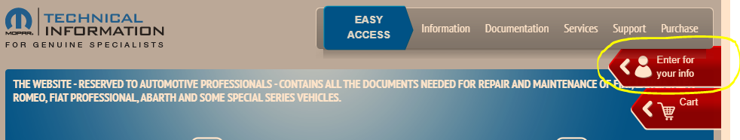
If you are a new user you will need to Register and if you are a returning user you will use your pre-existing credentials to login.

For new users you will then have to agree to the General Conditions found on the next page.

The next page is your company information. You will either use the find button to locate your company if already registered with Mopar or use the new option to have your company entered into Mopar’s database.

All information with an asterisk will need to be filled in. Your VAT number is your TAX Identification number. Your accounting departments should be able to help you locate this number. Also, where is has the option to attach a file in the bottom left circled in yellow, this is where you must upload an image of your business card.

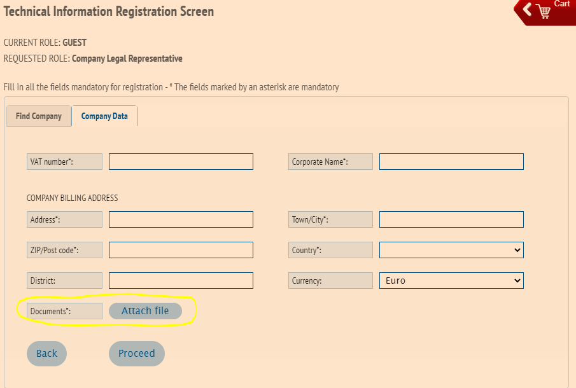

After completing these steps the last few steps are fairly simple and should be able to be completed with ease.
Please note that currently you are not able to change the currency format to USD, but it will be converted when the charges are ran on whatever form of payment you choose.
After completing the registration you will need to wait for Mopar to contact you at the email address that you provided to complete the registration process. Once this has been completed you can use the main page to purchase the desired subscription length for the FCA SGW Access. Once you have purchased your access you can then use the ID and password affiliated with your account inside the TEXA software to gain access to the desired SGW modules that you are needing to interact with.

If you have any questions please reach out to Mopar’s support line or us here at Cutting Edge, but please note that Mopar will not be able to assist us on your behalf, but we can help with general questions.

